Project Phase - III -> Implement Frameworks the DevOps way

# Make an E-commerce Website for Sporty Shoes - sportyshoes.com

This Project is developed by Siddhant Mhatre. This project is hosted on the git repository: [https://github.com/Mscitsid/Make-an-E-commerce-Website-For-](https://github.com/Mscitsid/Make-an-E-commerce-Website-For-SportyShoes-sportyshoes.git) [SportyShoes-sportyshoes.git](https://github.com/Mscitsid/Make-an-E-commerce-Website-For-SportyShoes-sportyshoes.git)

# PROJECT DESCRIPTION

This application is designed and developed as an e-commerce portal sportyshoes.com for a walk-in store. This system allows Administrator to create (add), read (list), update and delete the customers of the application as well as the products of the application. This project helps the administrator to manage the products and the customers well. The customer can login into the system as well as view the products added in the portal by the authorized admin

## TECH STACK

* + - * Core Java Concepts - Object Oriented Programming (OOPS) Concepts such as Classes and Objects.
      * Collections such as Set , List
      * Loops such as For Loops
      * Java Servlet
      * JDBC template
      * SQL - MySQL database
      * JSP
      * Maven
      * Spring MVC Framework
      * Tomcat Server 9v

# FLOW CHART OF THE APPLICATION

The below given picture depicts the flow of the Project:

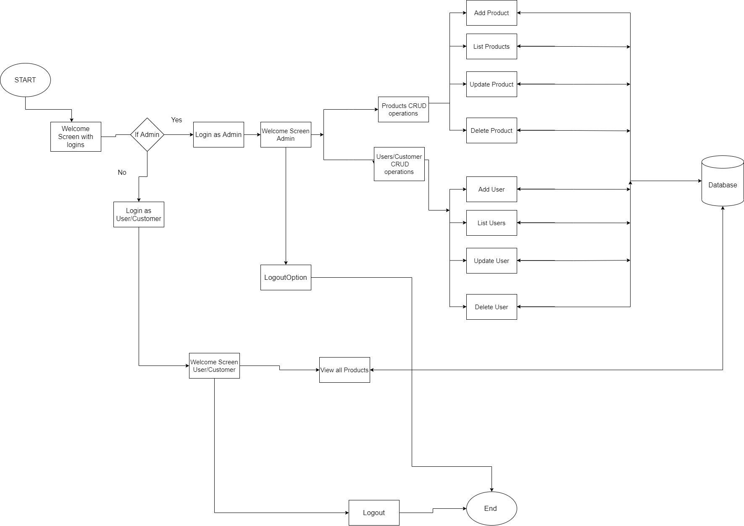

**FIG 1 - FLOW CHART OF THE PROJECT**

# PROJECT USER STORIES : (Agile and Scrum)

* + As a user I want E-commerce portal for the walk-in store to better manage the details of Products and Customers.
  + As a user I want a login page.
  + As a user I want to view list consisting of all the Products.
  + As a user I want to view list consisting of all the Customers.
  + As a user I want to add, update, and delete products and customers.
  + As a user I want to allow customers to view all the products on the e-commerce portal.
  + As a developer I want to develop an application for E-commerce portal for walk-in shoe store.
  + As a developer I want to develop an application in which proper single administrator login is there.
  + As a developer I want to develop an application in which multiple customers registered into the system can login.
  + As a developer I want to develop an application in which user (administrator) is able to view list of products, customers from a database.
  + As a developer I want to develop an application in which user (administrator) is able to add, update and delete details of products, customers from a database.

# SPRINTS

**Sprint 1**

* + Understanding the problem statement of the project.
  + Creating the flow chart of the application.
  + Creating Maven Project.
  + Adding necessary dependencies.
  + Creating necessary xml files
  + Creating Controller, DAO as well as Entity Packages and Classes needed.
  + Writing the Java servlet for login of Administrator.
  + Writing JDBC template to connect with the database MySQL.
  + Testing at each step for different user inputs.
  + Initializing the git repository.
  + Pushing the code to the GitHub
  + Creating the Specification document for showing the Product’s capabilities, appearance and the user interactions.

# PROJECT GIT REPOSITORIES

1. Link to the GitHub Repository :

[https://github.com/Mscitsid/Make-an-E-commerce-Website-For-SportyShoes-](https://github.com/Mscitsid/Make-an-E-commerce-Website-For-SportyShoes-sportyshoes.git) [sportyshoes.git](https://github.com/Mscitsid/Make-an-E-commerce-Website-For-SportyShoes-sportyshoes.git)

1. clone git :

[https://github.com/Mscitsid/Make-an-E-commerce-Website-For-SportyShoes-](https://github.com/Mscitsid/Make-an-E-commerce-Website-For-SportyShoes-sportyshoes.git) [sportyshoes.git](https://github.com/Mscitsid/Make-an-E-commerce-Website-For-SportyShoes-sportyshoes.git)

1. Screen Shot of GitHub :

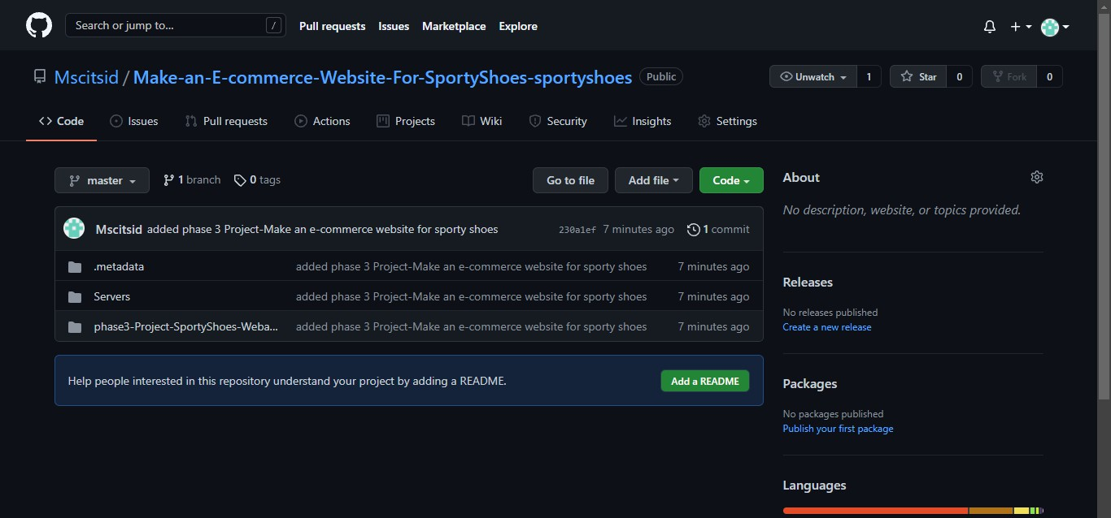

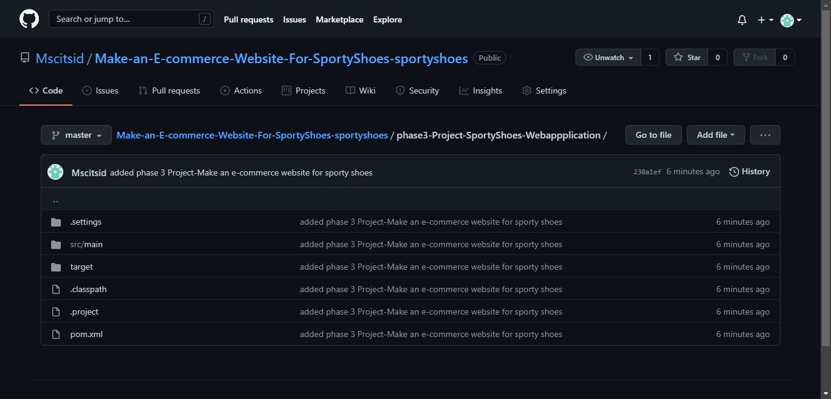

1. How to run Project :
   1. Clone project

Clone git: git clones

[https://github.com/Mscitsid/Make-an-E-commerce-Website-For-SportyShoes-](https://github.com/Mscitsid/Make-an-E-commerce-Website-For-SportyShoes-sportyshoes.git) [sportyshoes.git](https://github.com/Mscitsid/Make-an-E-commerce-Website-For-SportyShoes-sportyshoes.git)

4.2 First create Database and some values for products and customers by running these queries in MySQL Workbench

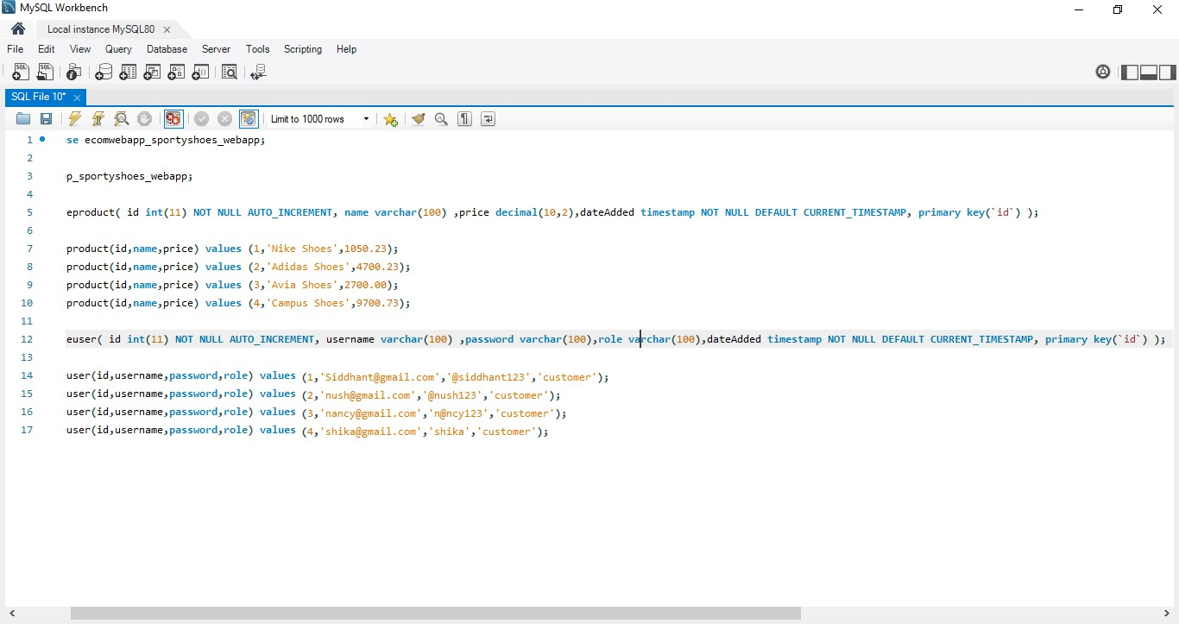

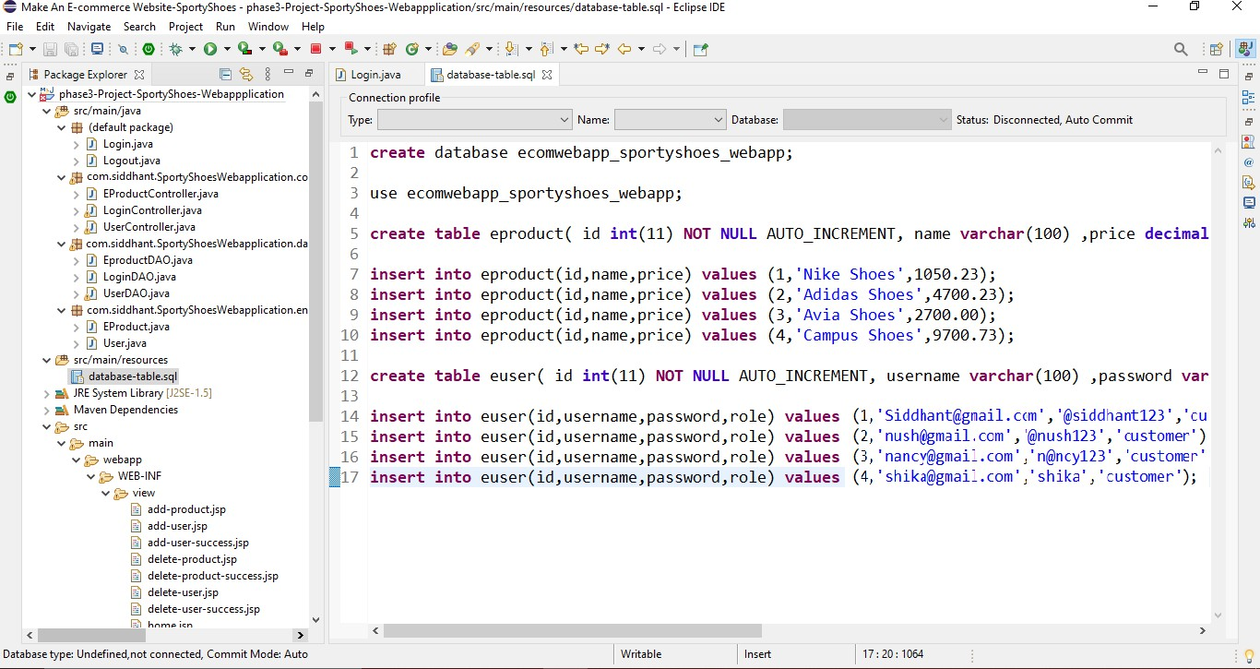

* 1. Open Make-an-E-commerce-Website-For-SportyShoes-sportyshoes->phase3-Project- SportyShoes-Webapplication ->src->main->java->com->siddhant->SportyShoesWebapplication

Right click on the project -> Run As ->Run on Server

* + - Name of Project ->>**phase3-Project-SportyShoes-Webapplication**
    - Name of Package ->> **com.siddhant.SportyShoesWebapplication**

## DIRECTORY STRUCTURE / PACKAGE

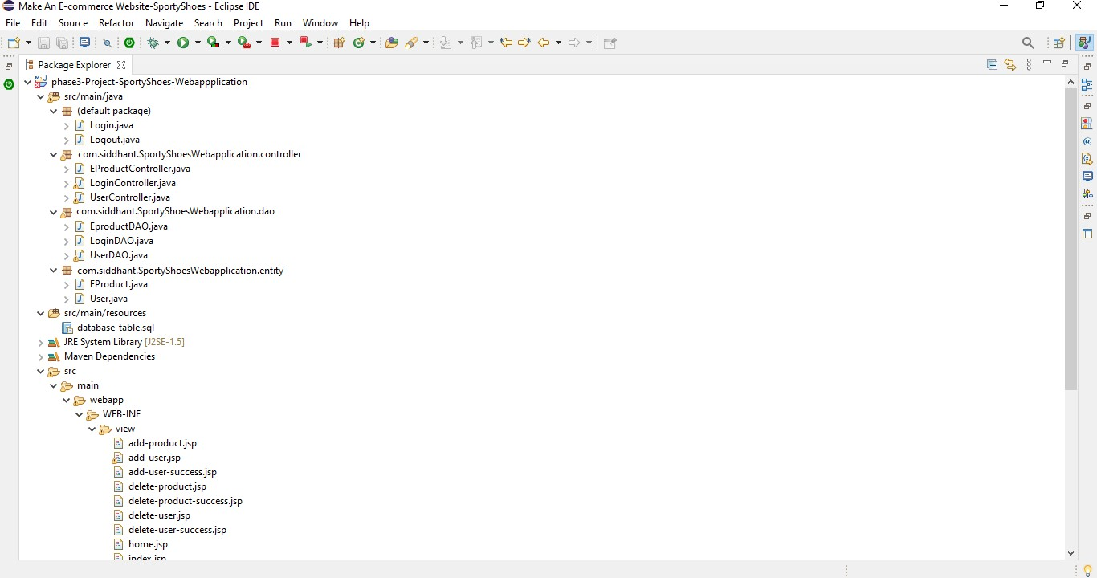

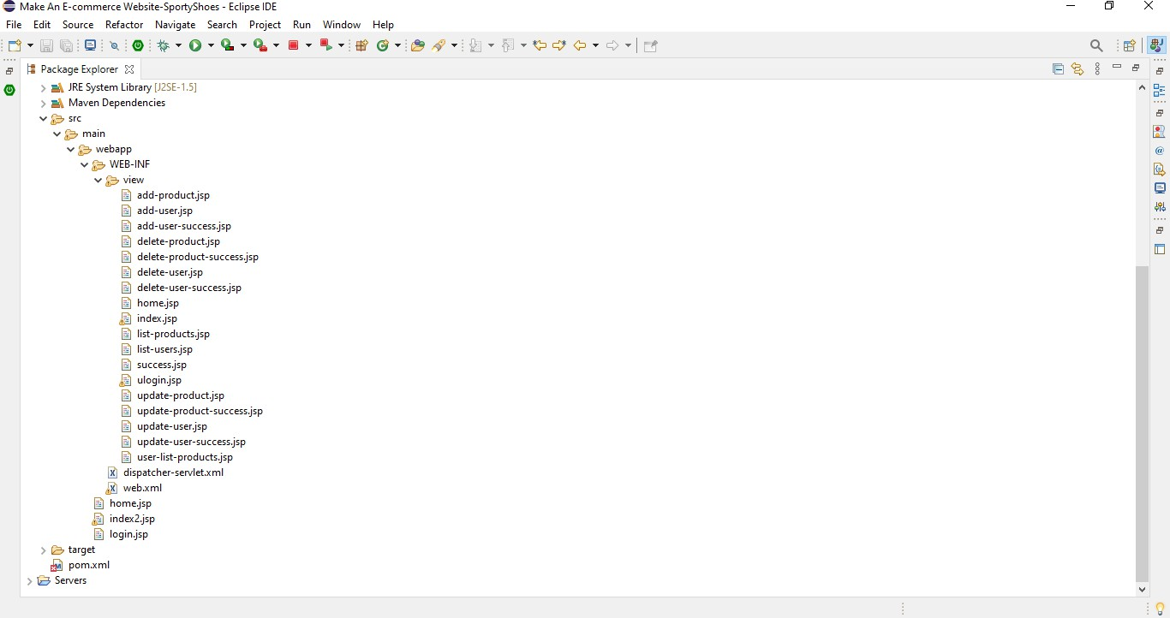

* + - **SCREENSHOTS OF pom.xml**

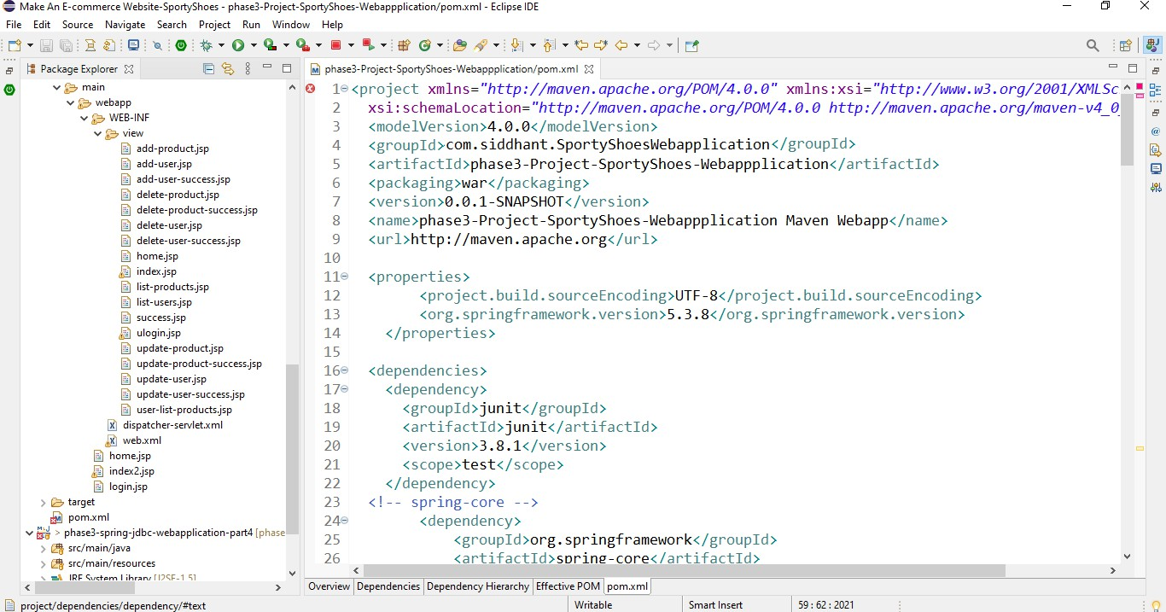

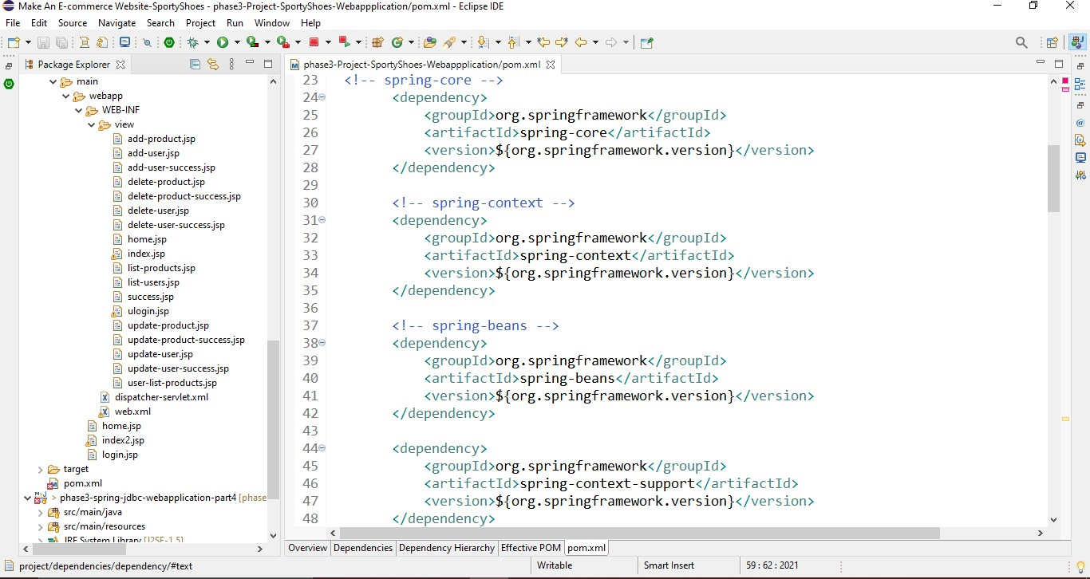

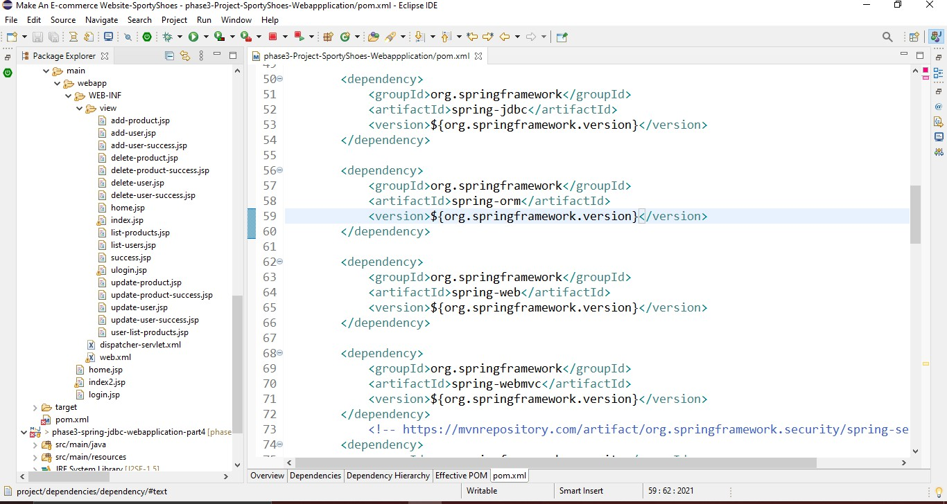

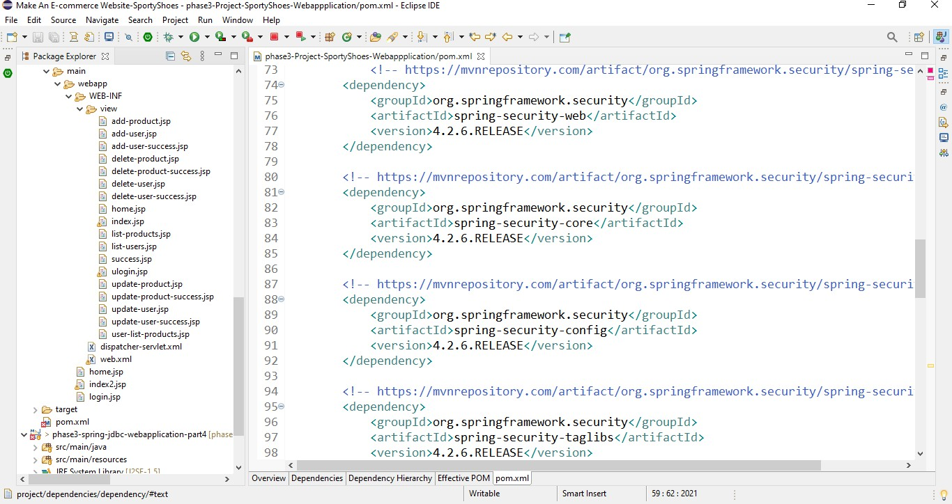

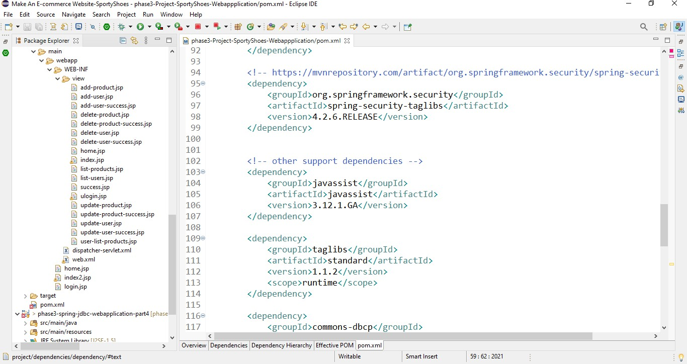

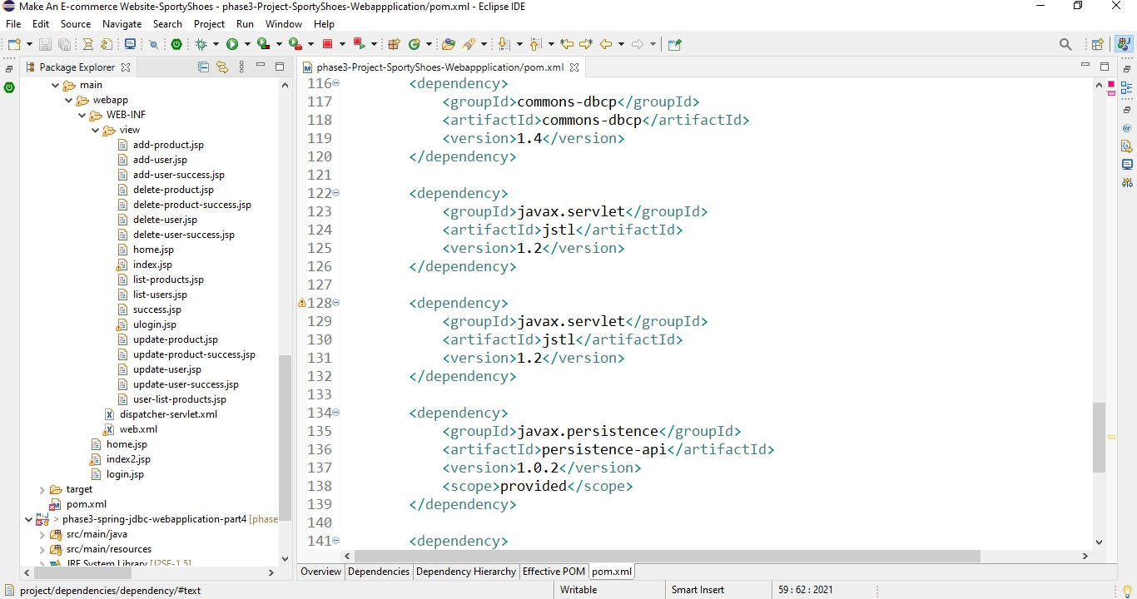

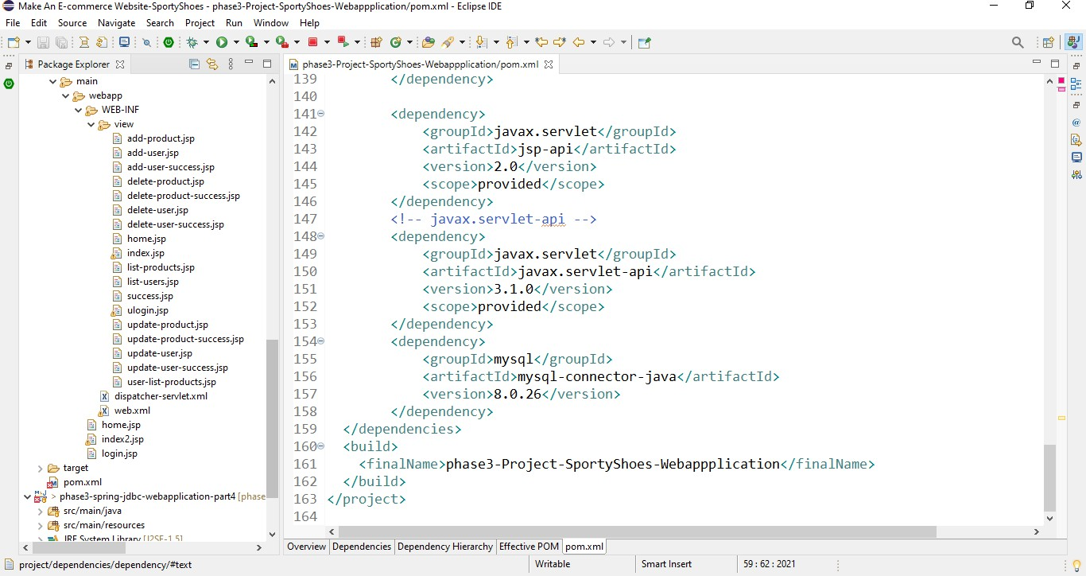

* **SCREENSHOTS OF web.xml**

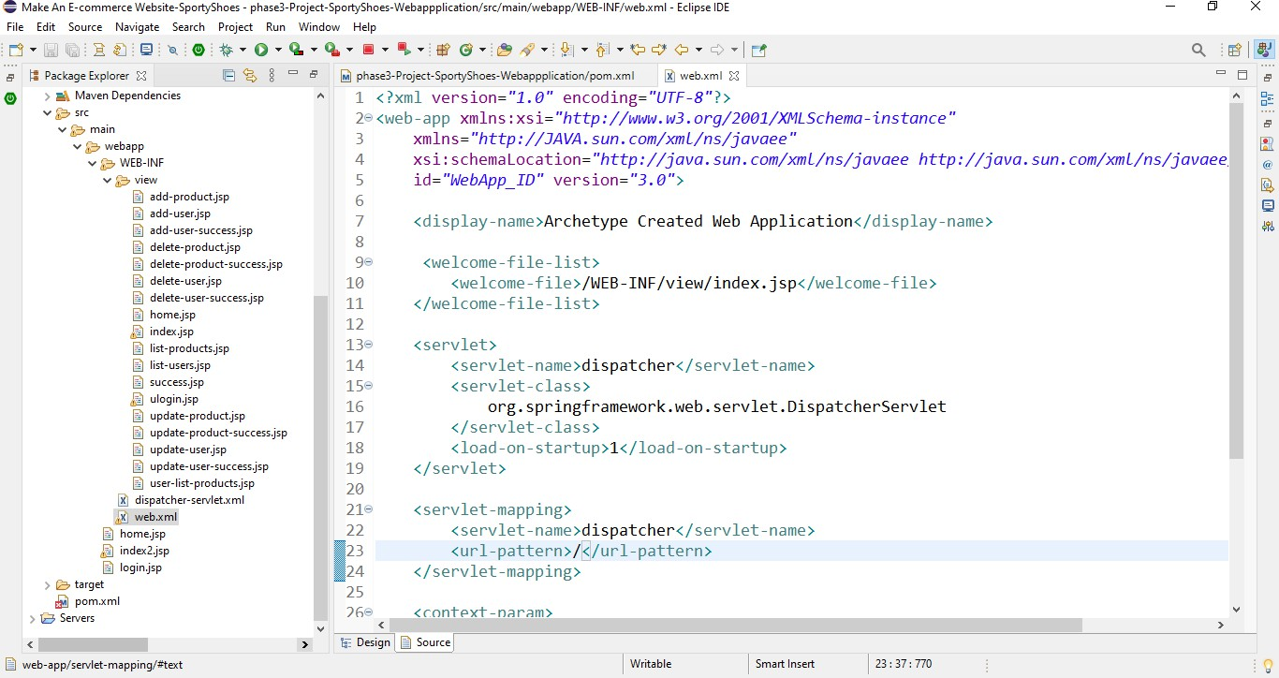

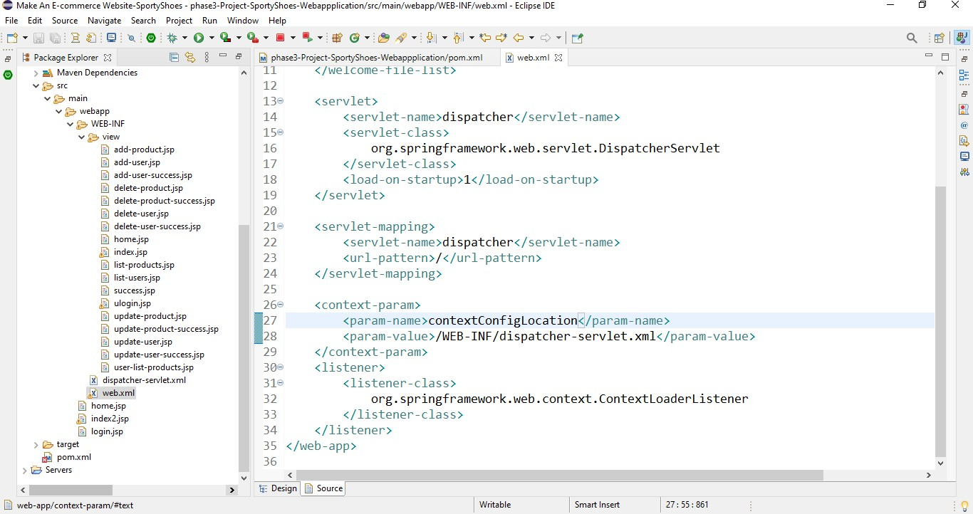

* **SCREENSHOTS OF dispatcher-servlet.xml**

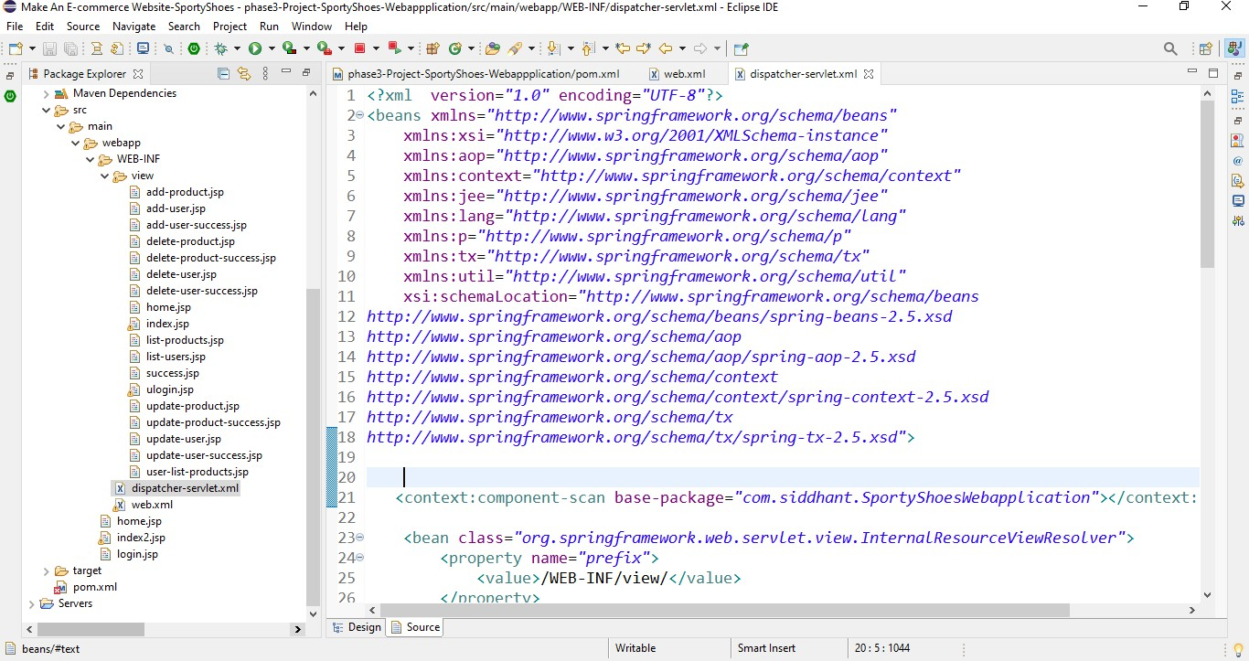

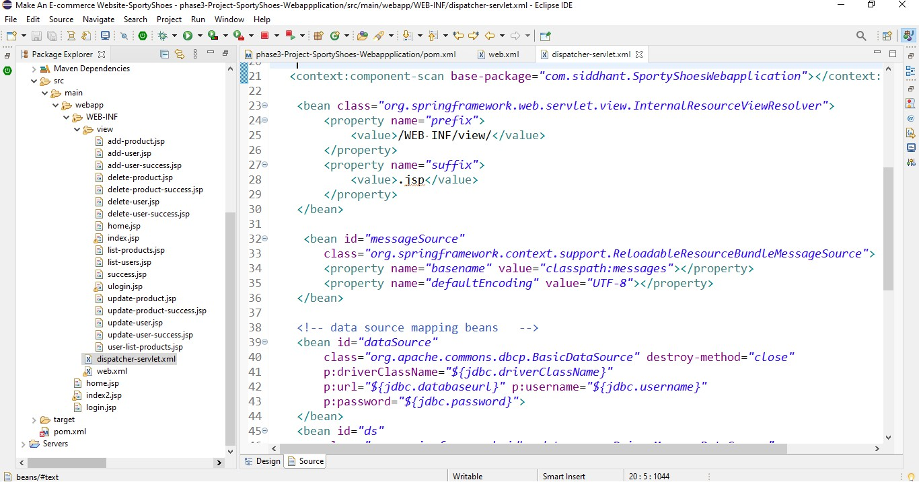

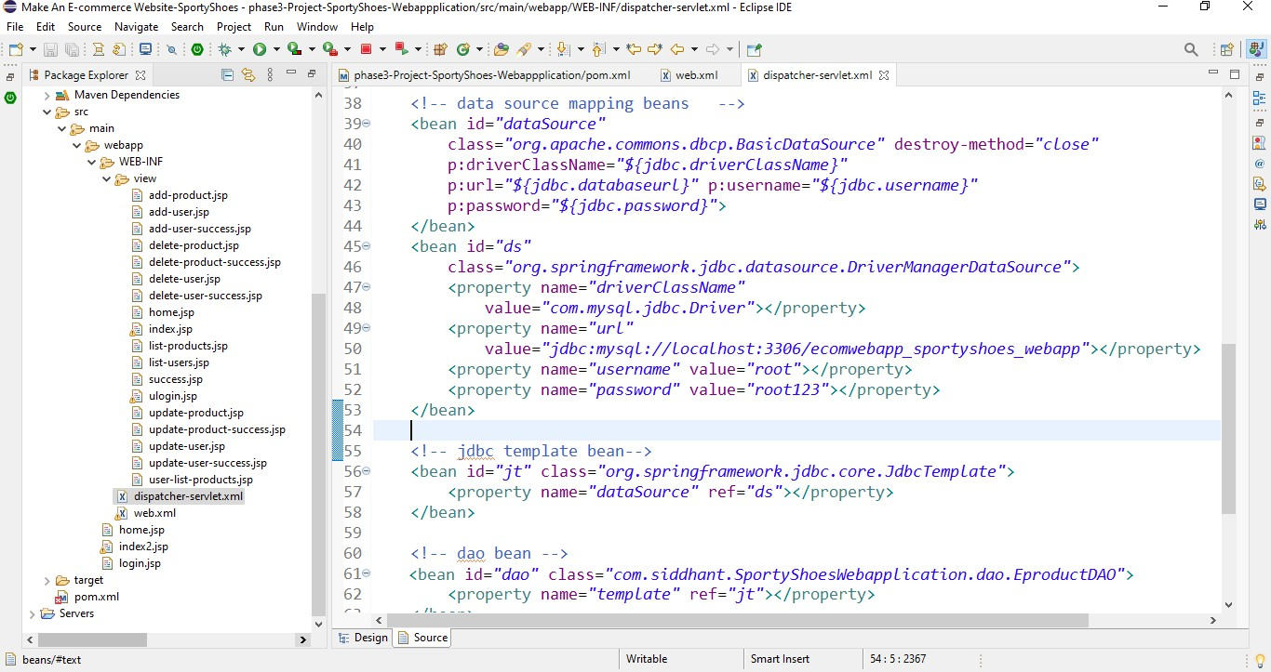

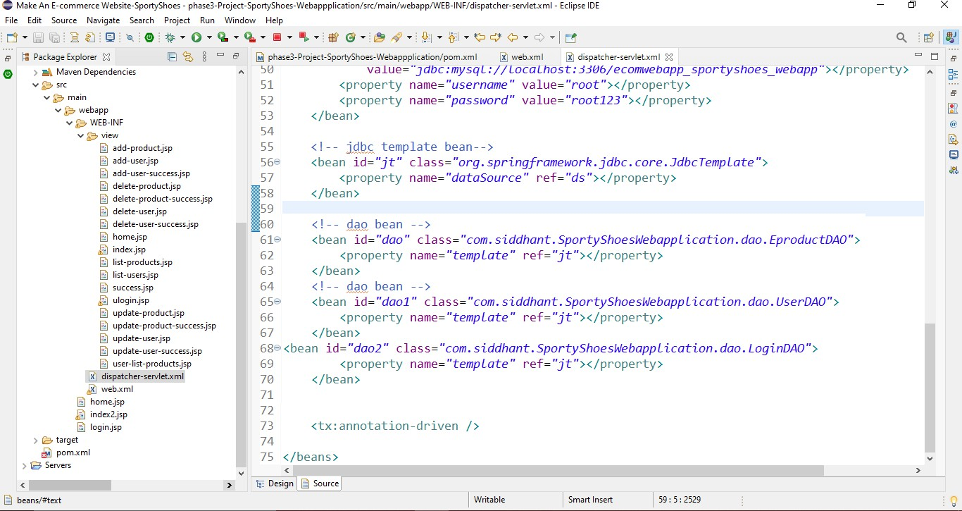

## SCREENSHOTS OF OUTPUT

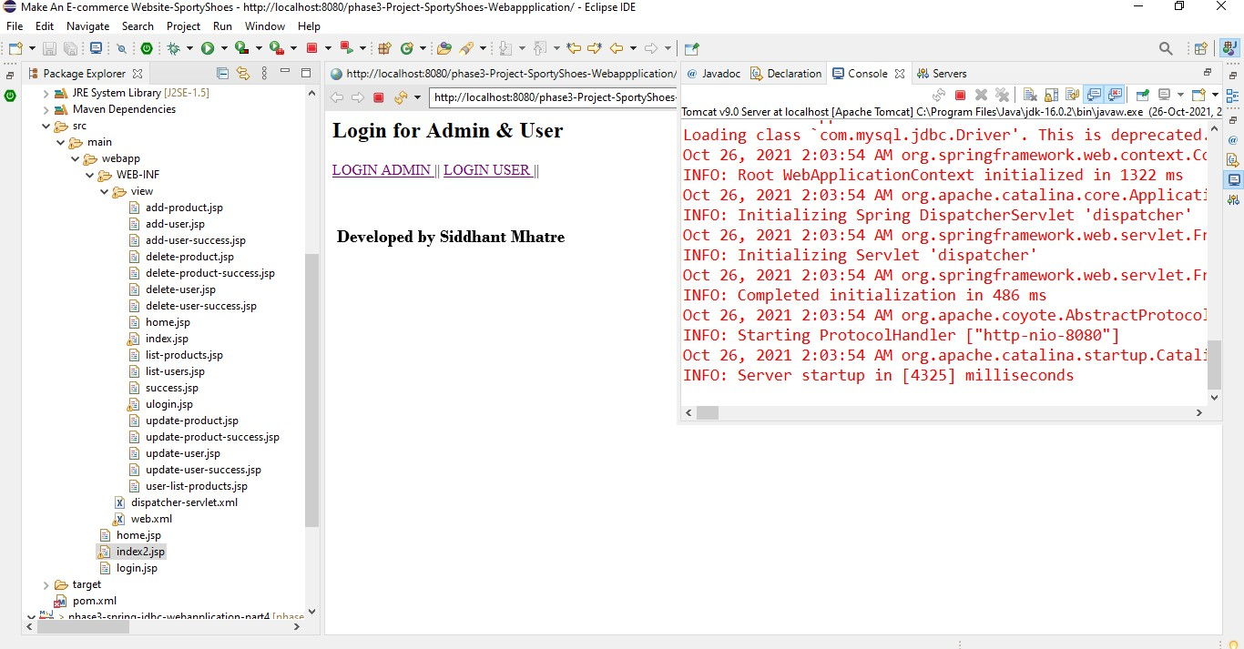

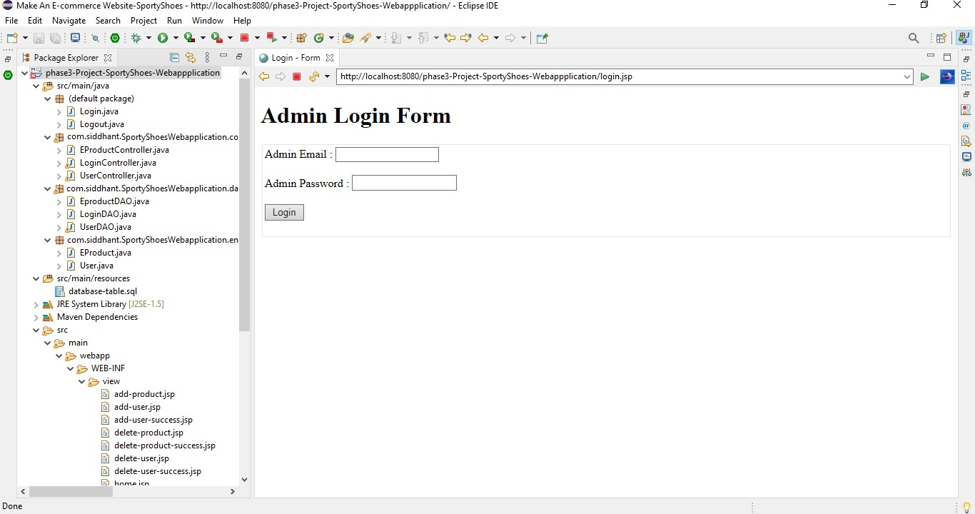

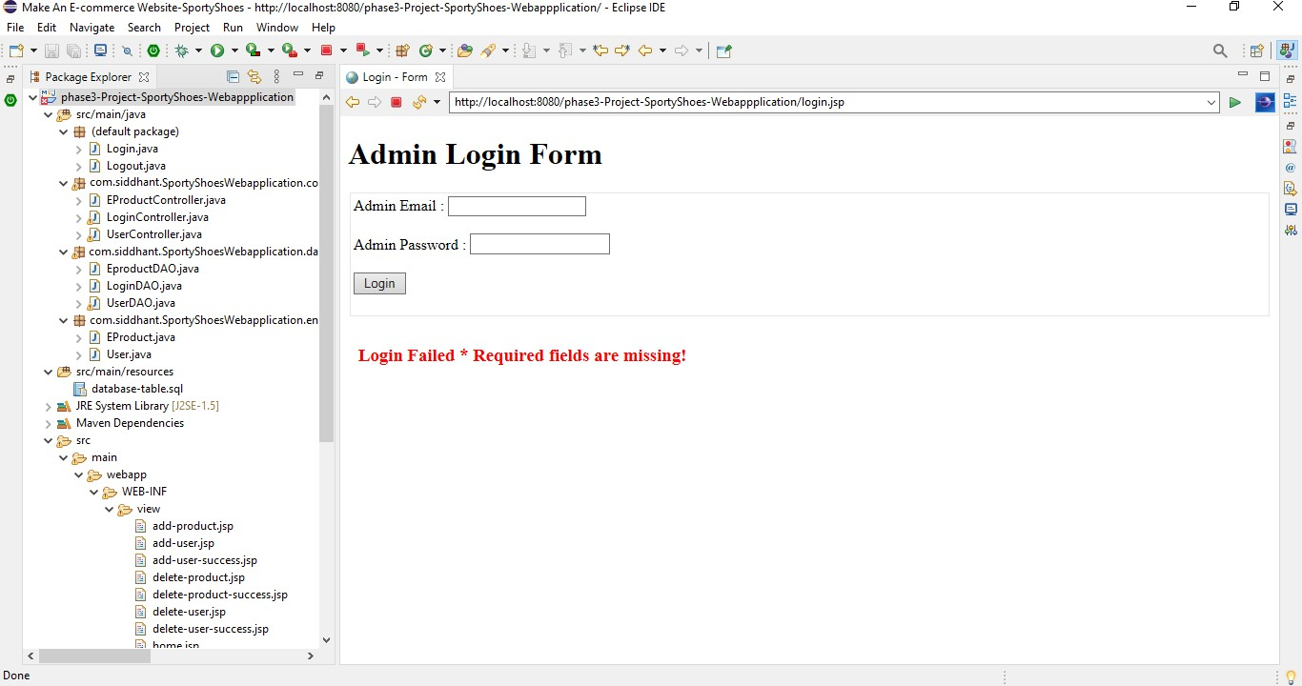

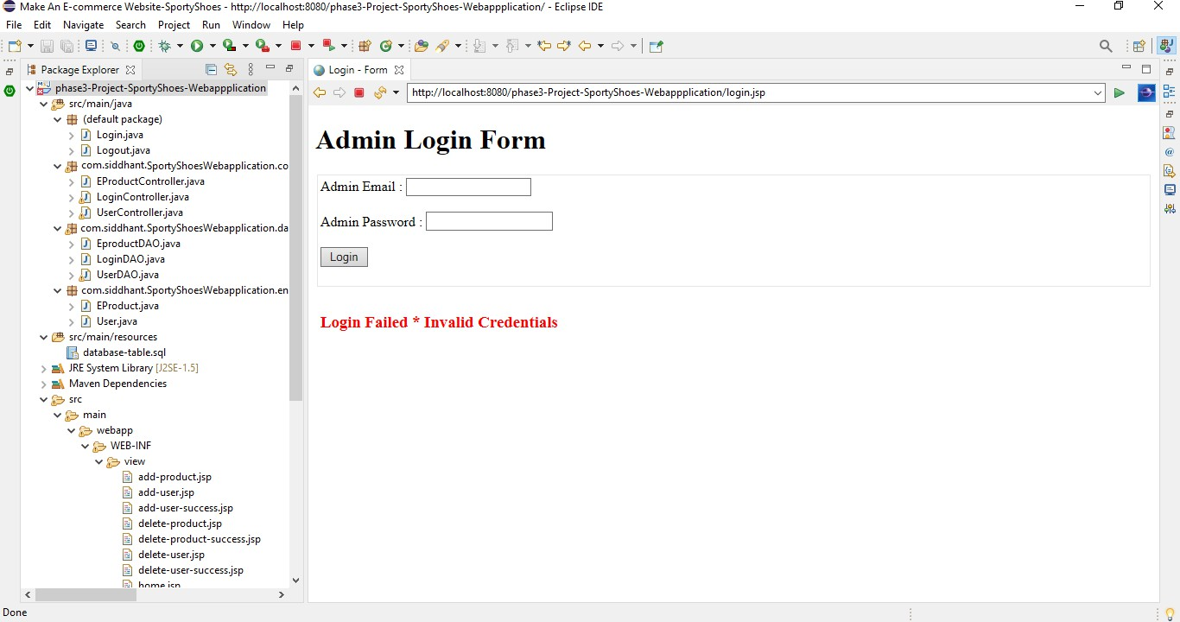

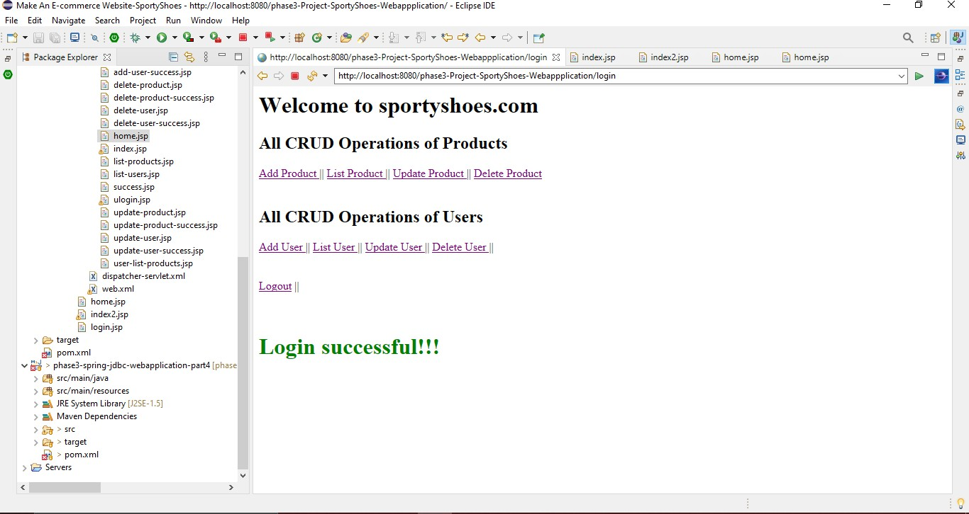

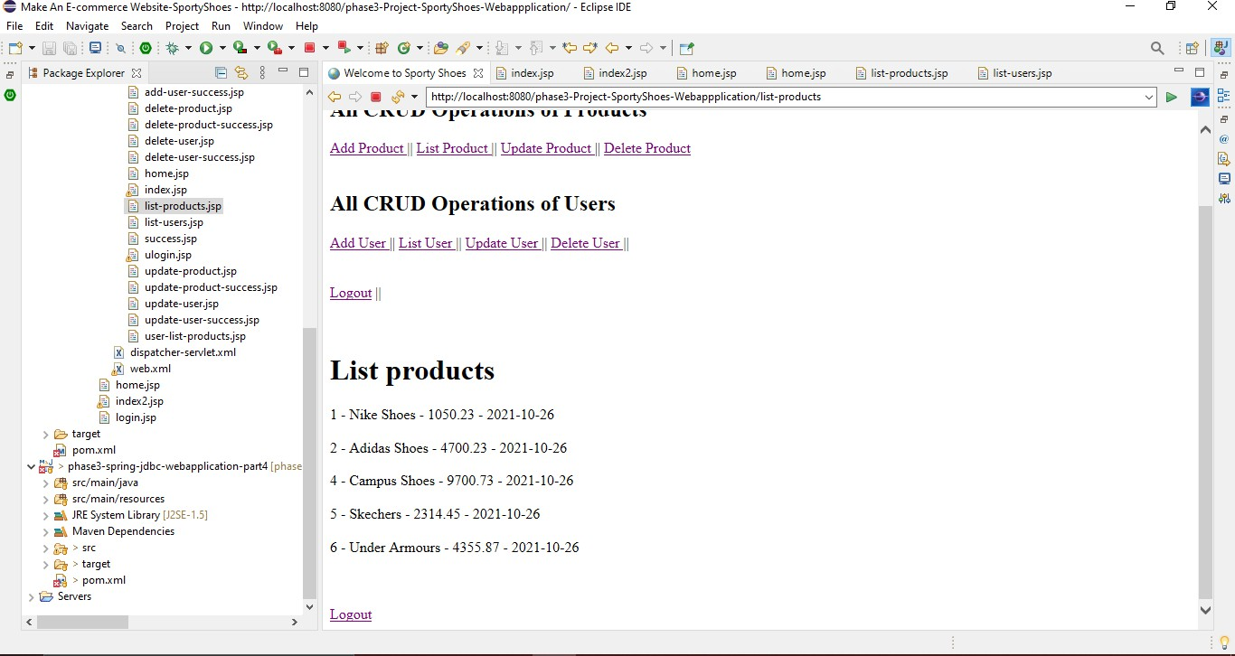

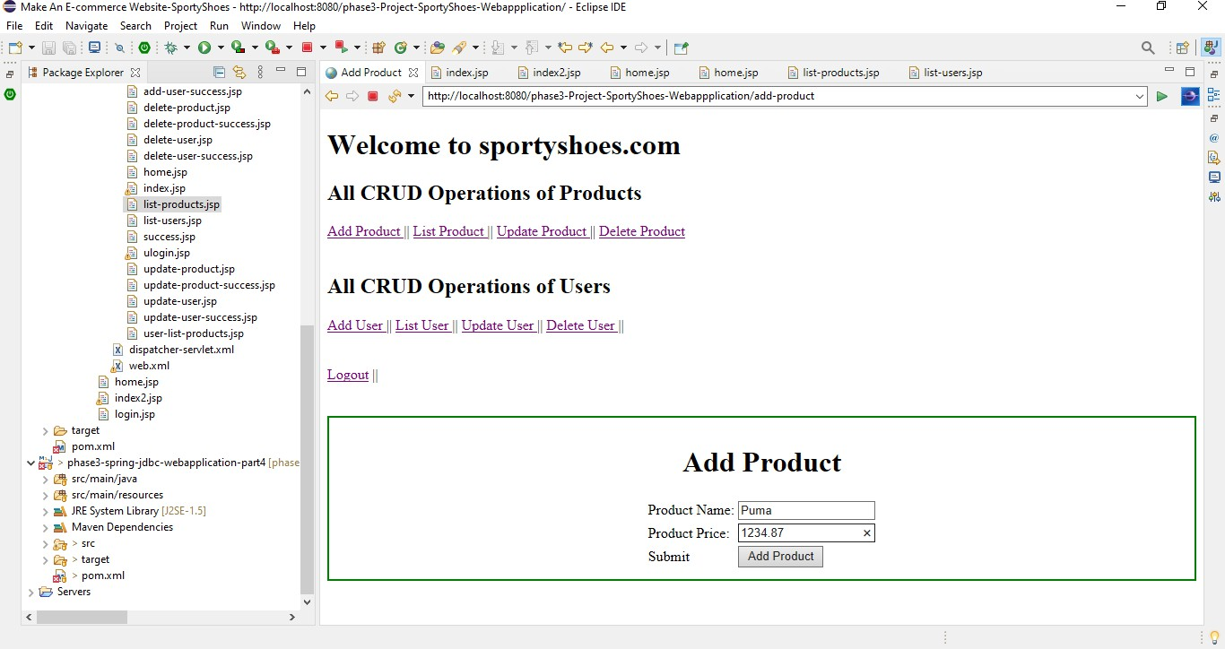

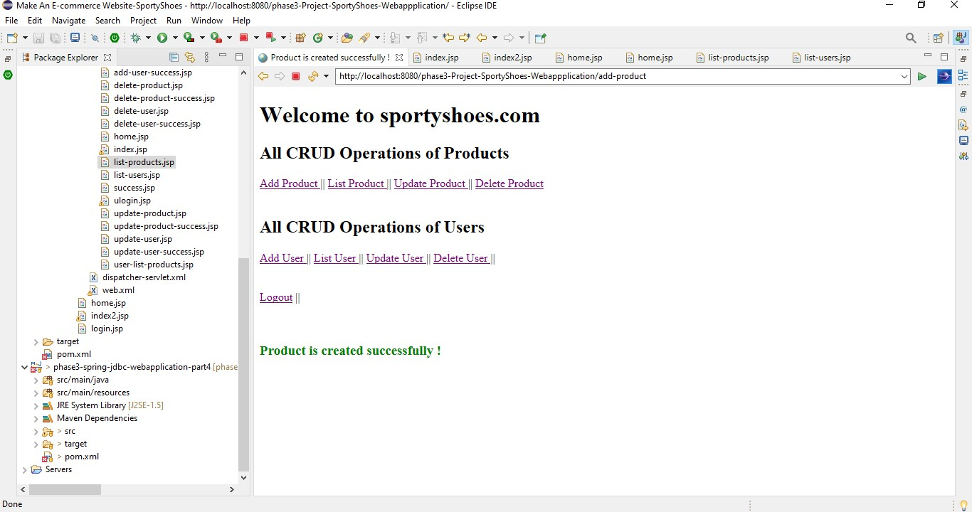

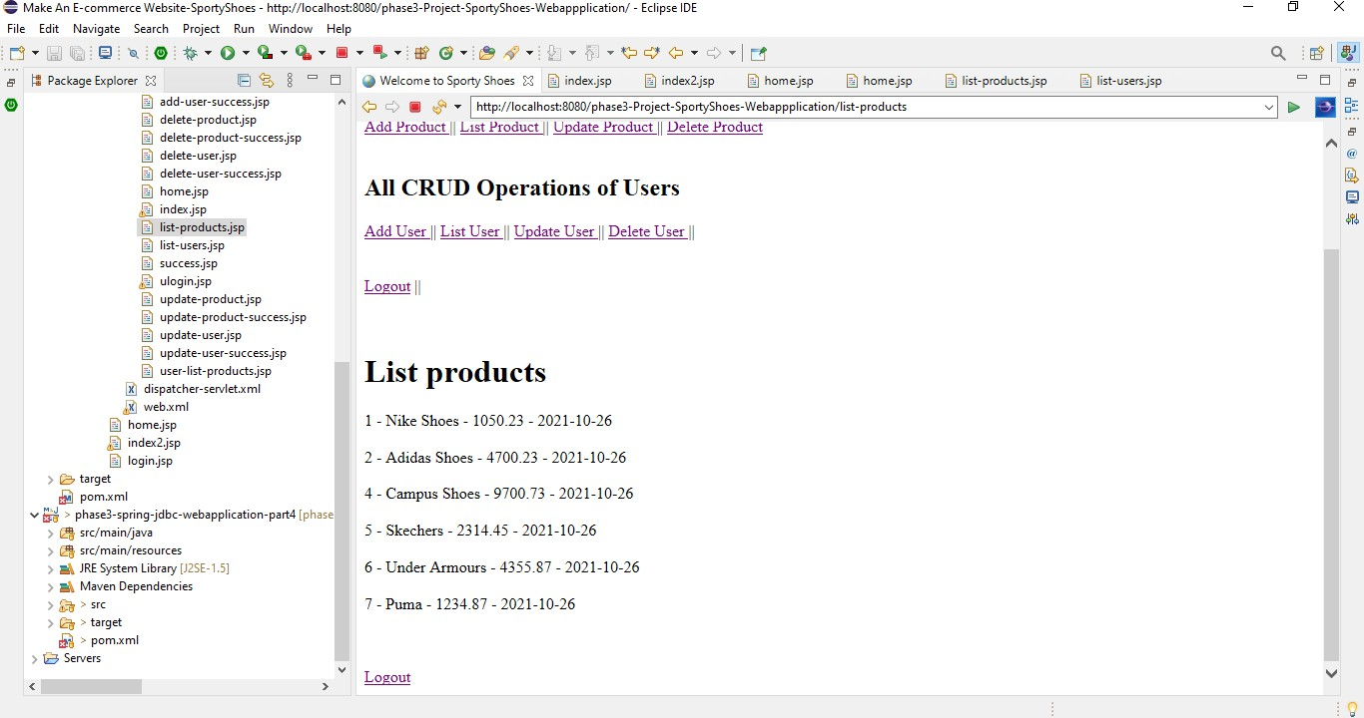

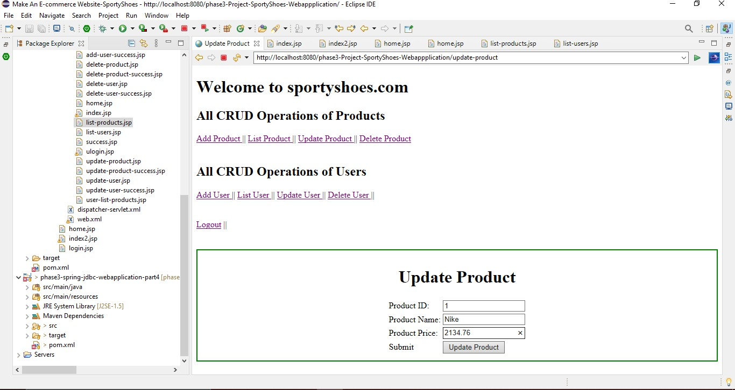

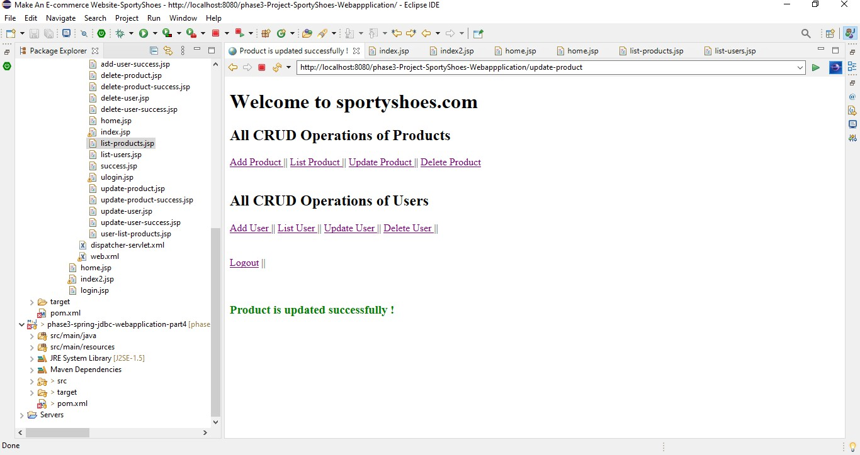

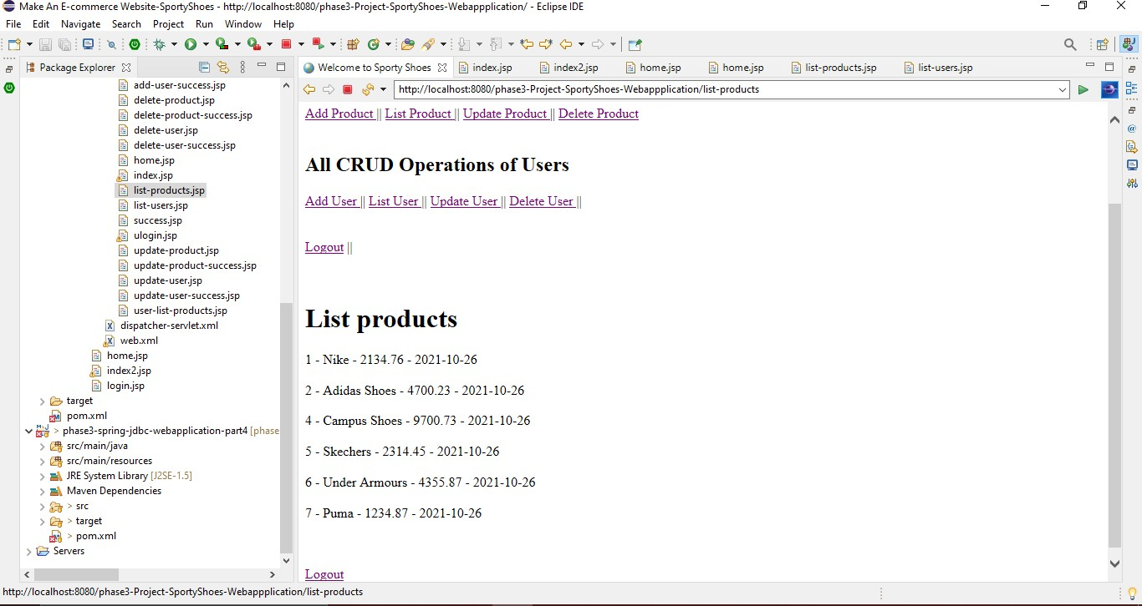

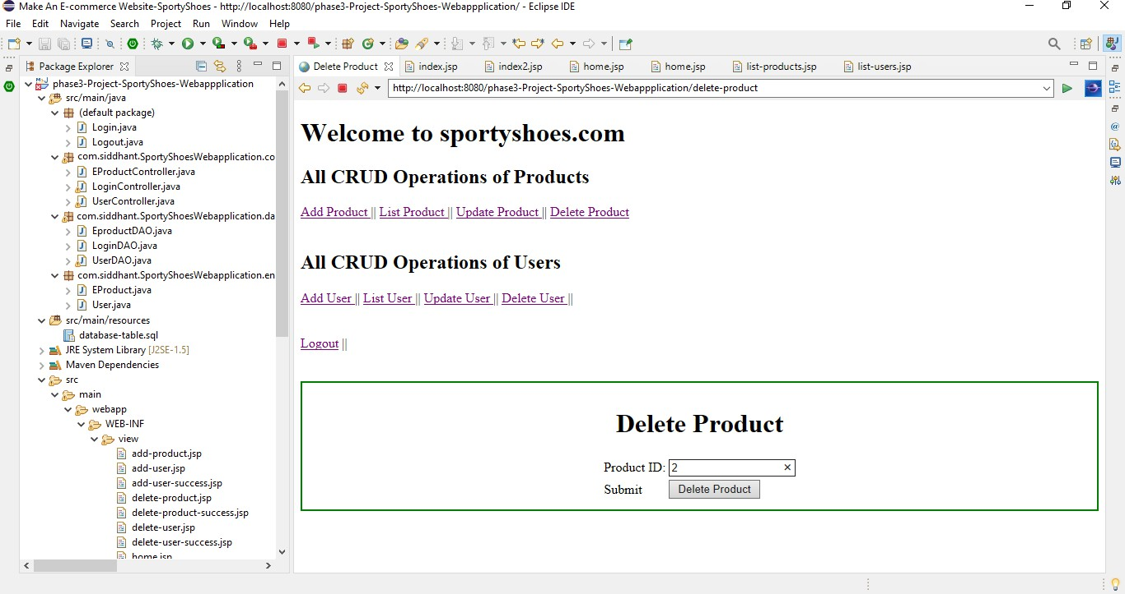

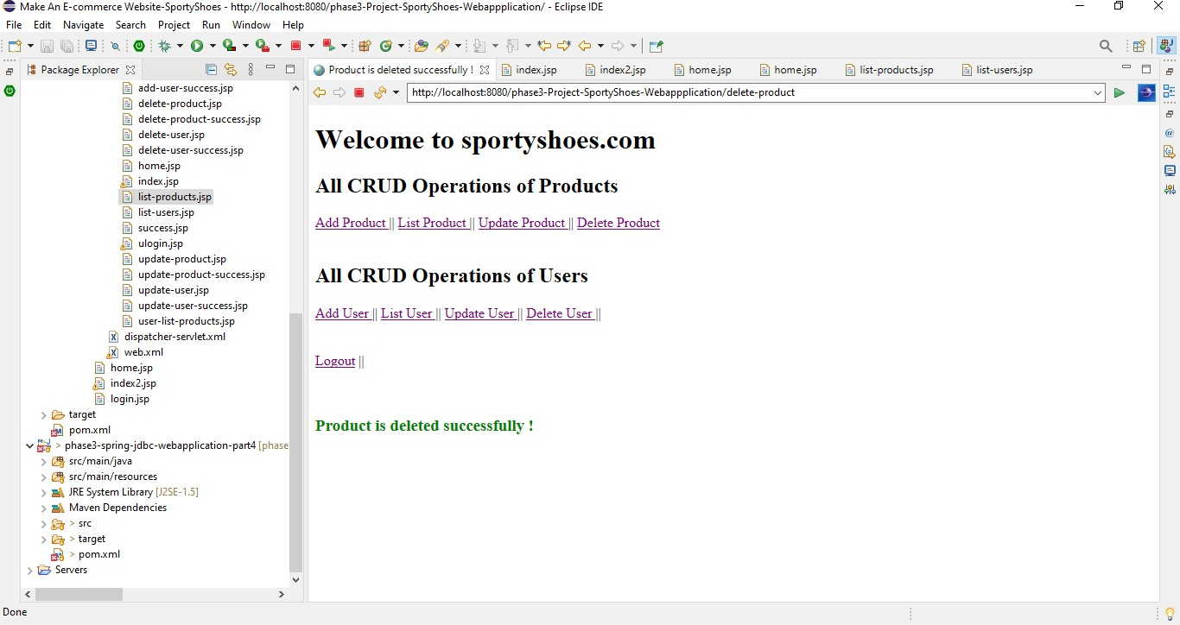

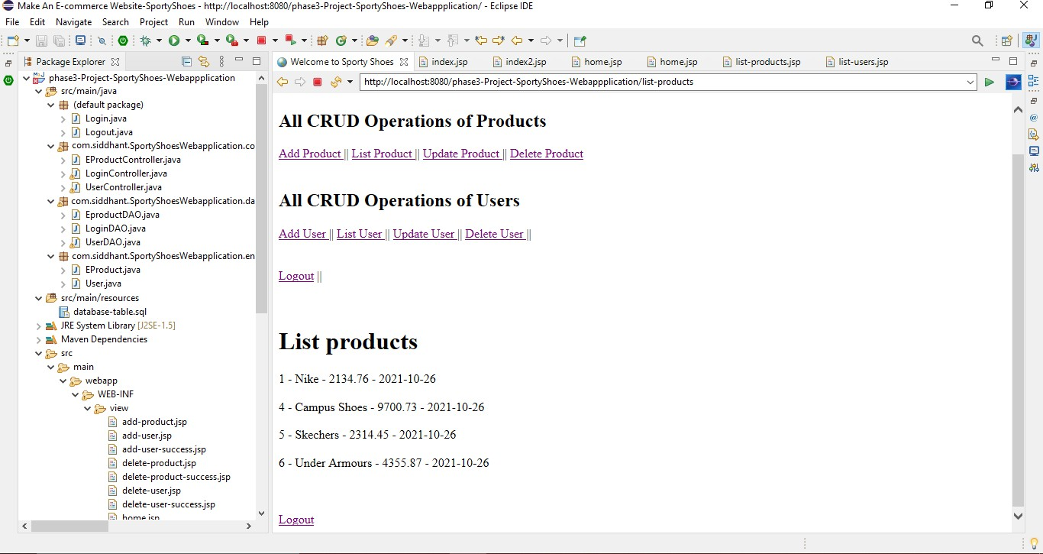

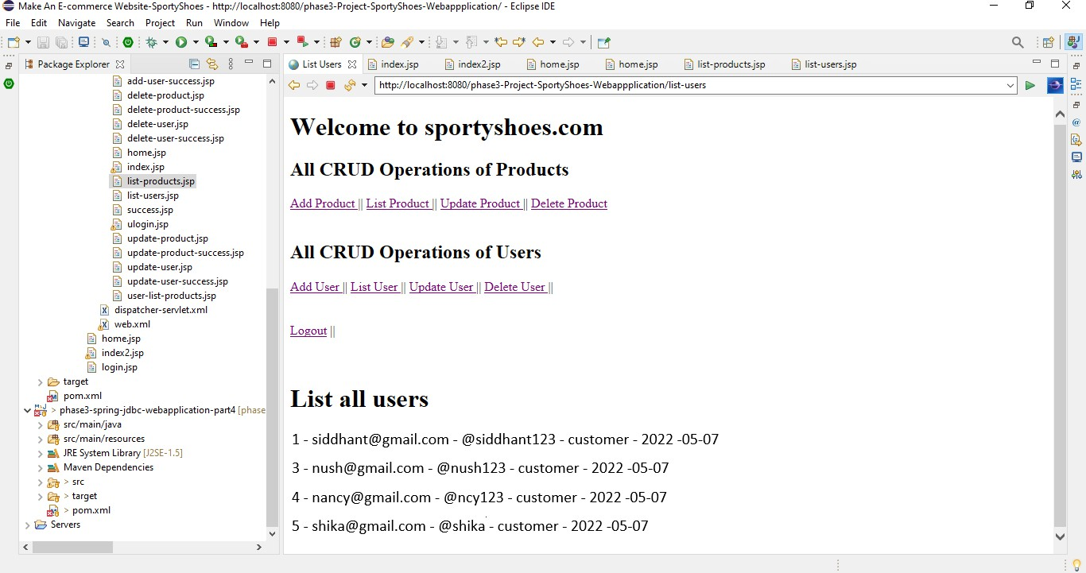

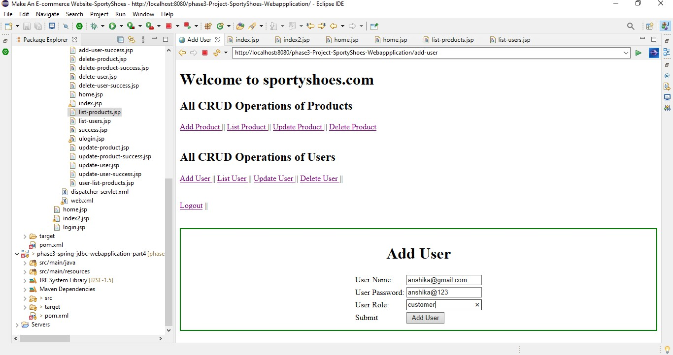

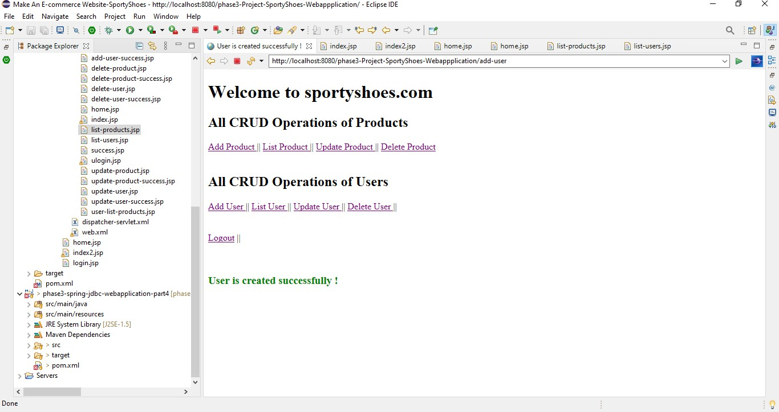

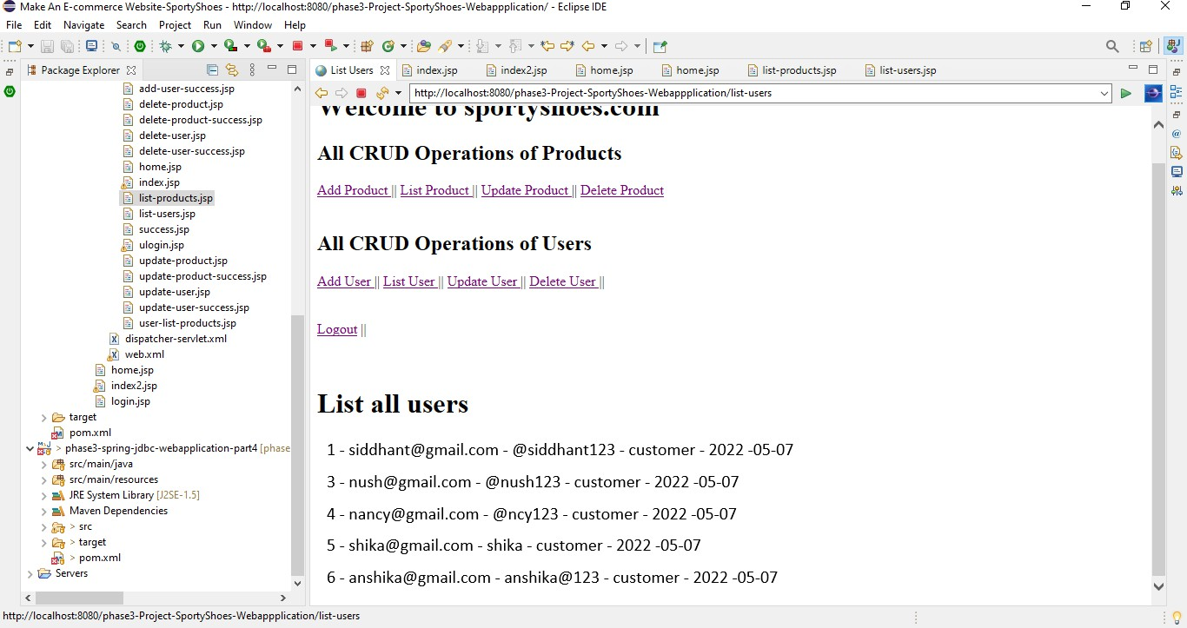

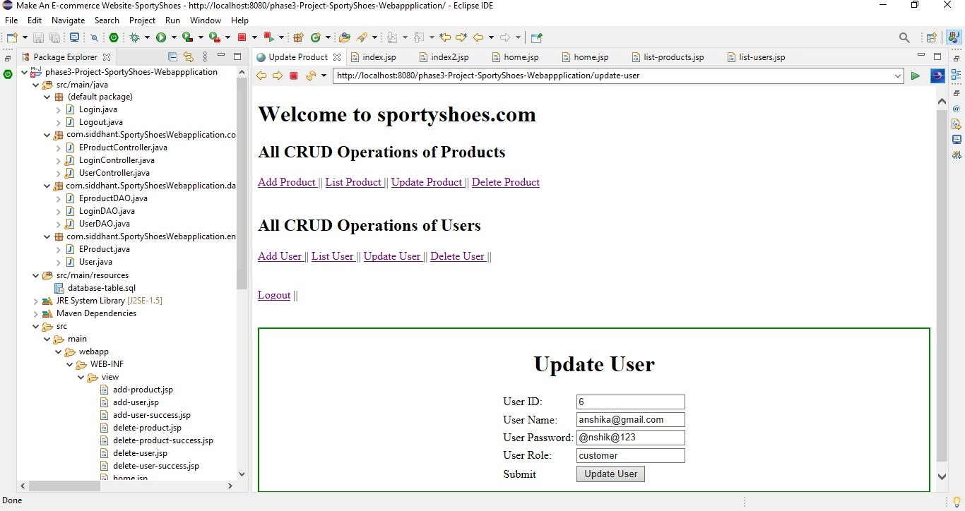

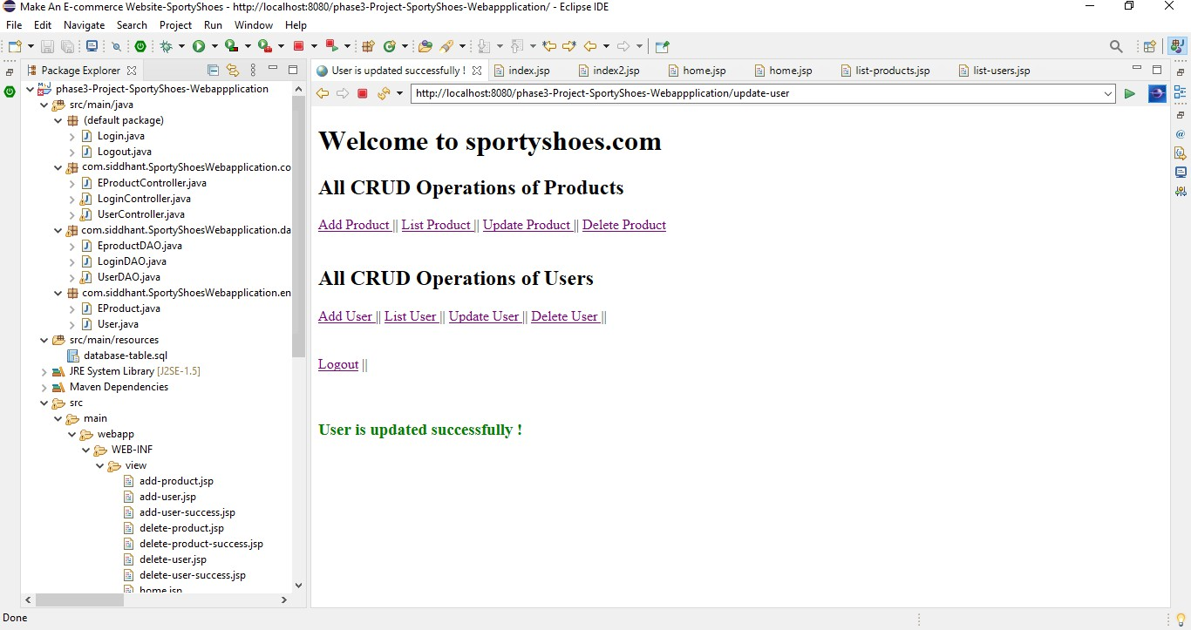

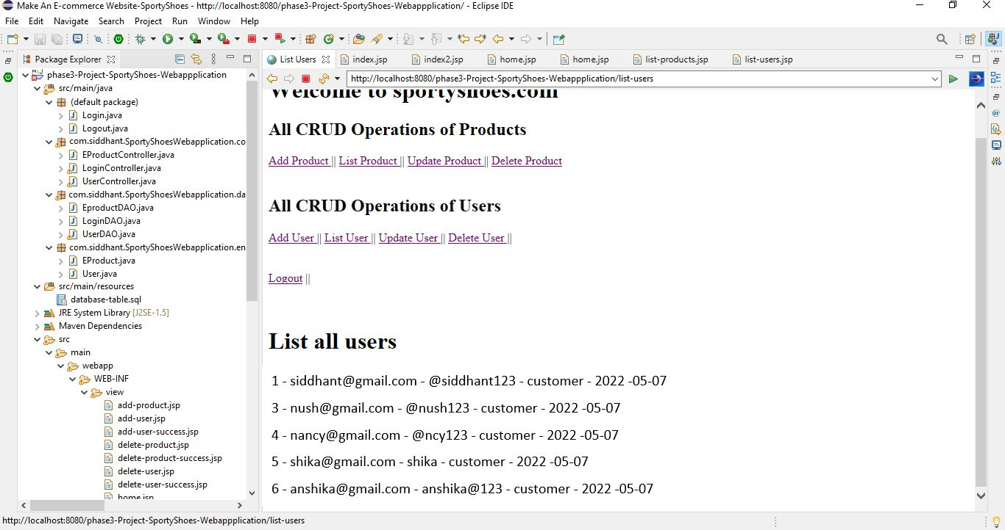

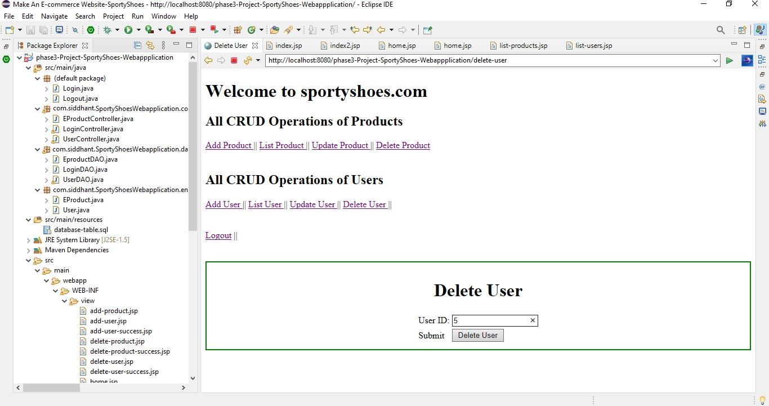

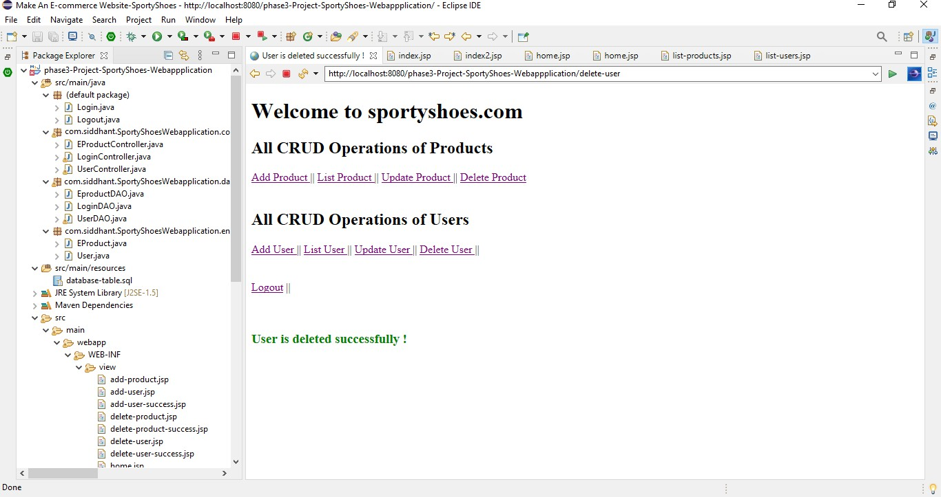

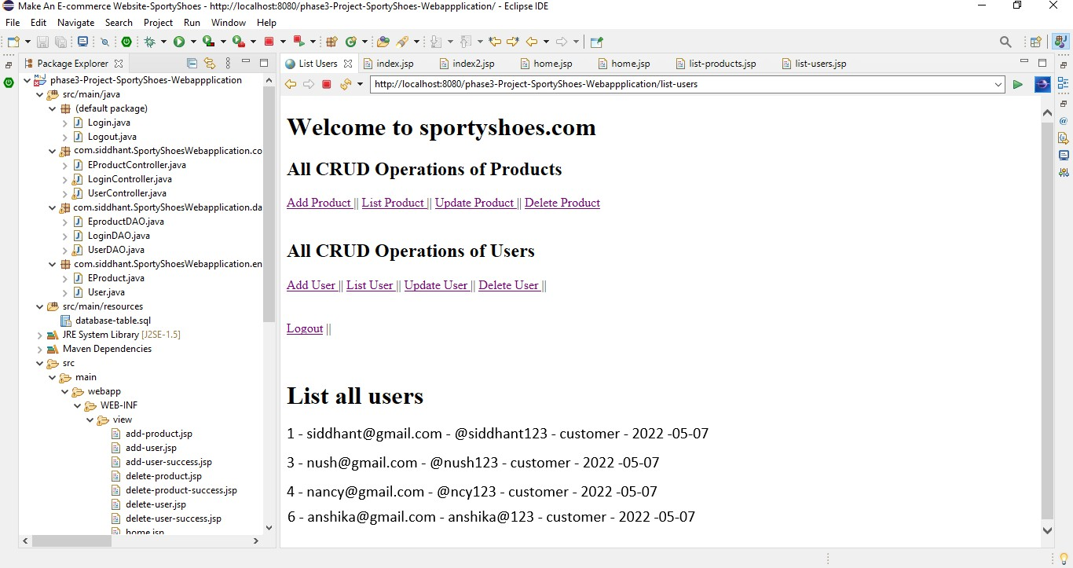

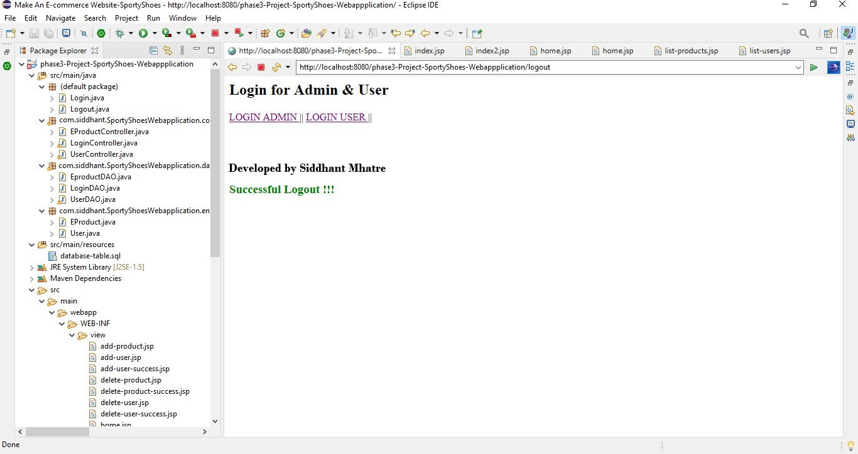

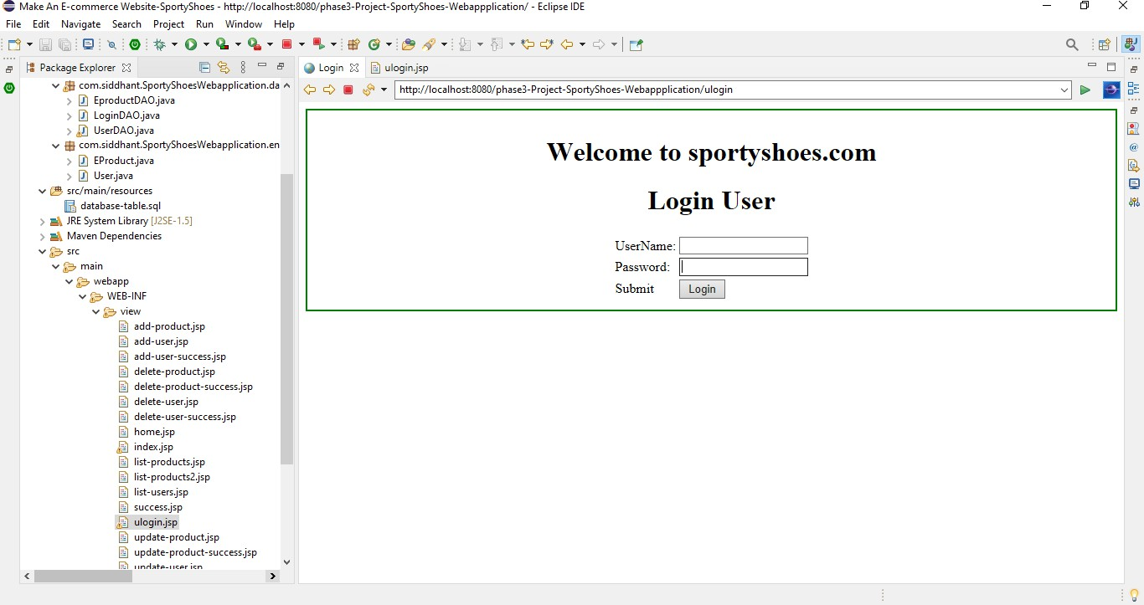

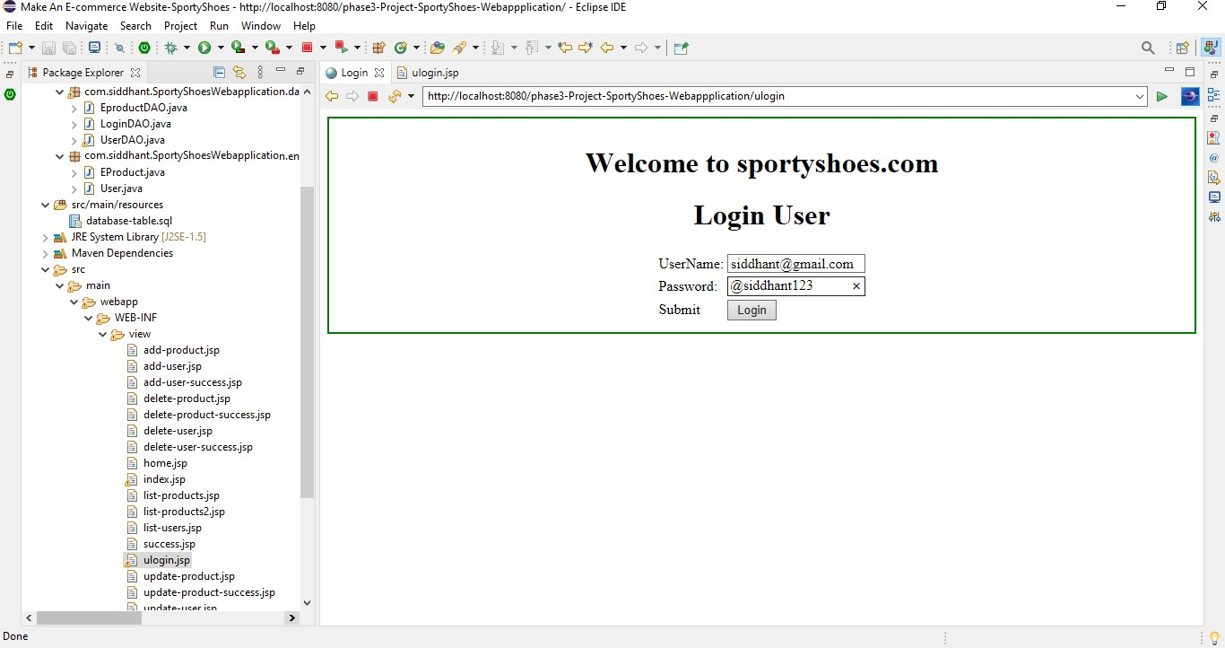

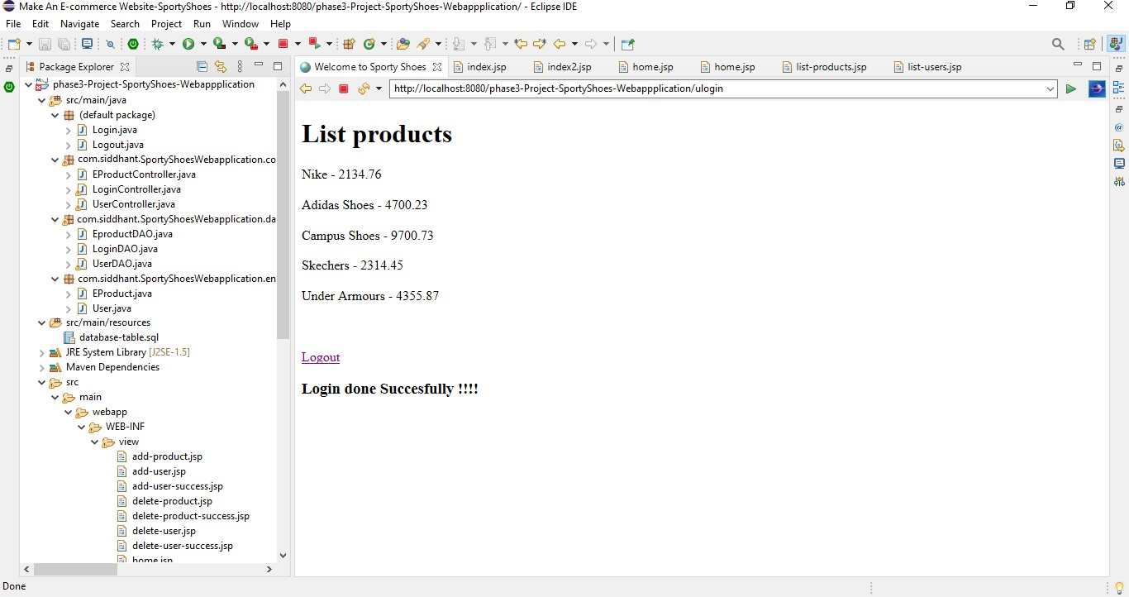

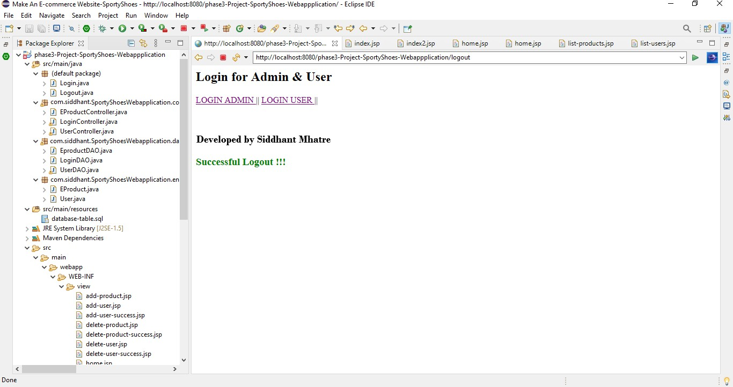

* **SCREENSHOT OF MySQL DATABASE**

